

<img loading="lazy">

Go to inspect and network .Now image will load when user will reach in image section

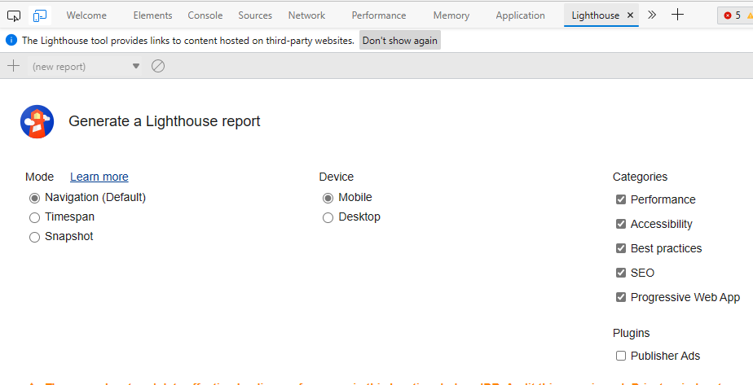

SEO:Correct path to you site(using lighthouse test)

<meta name="viewport" content="width=device-width, initial-scale=1">

This means that the browser will (probably) render the width of the page at the width of its own screen. So if that screen is 320px wide, the browser window will be 320px wide, rather than way zoomed out and showing 960px (or whatever that device does by default, in lieu of a responsive meta tag).

**Note:** [don’t](http://blog.javierusobiaga.com/stop-using-the-viewport-tag-until-you-know-ho) use a responsive meta tag if your website isn’t specifically designed to be responsive and work well at that size, as it will make the experience worse.

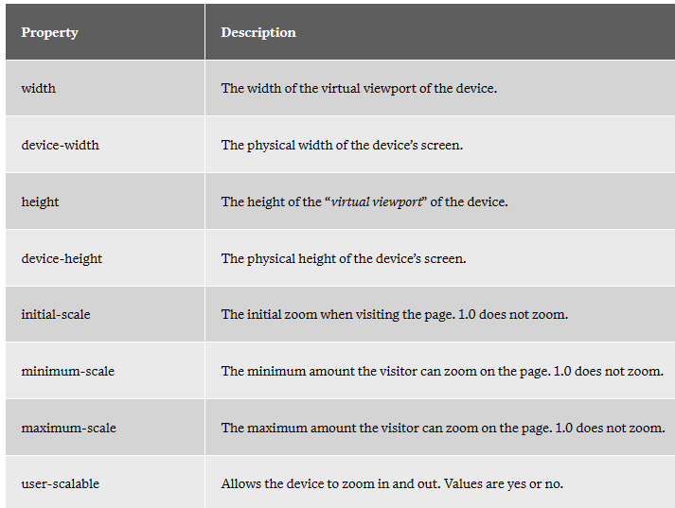

<meta> tags always go inside the <head> element, and are typically used to specify character set, page description, keywords, author of the document, and viewport settings.

Metadata is used by browsers (how to display content or reload page), search engines (keywords), and other web services.

<meta name="description" content="About your website">

<meta name="keywords" content="HTML, CSS, JavaScript,web development notes">

<meta name="author" content="Hari Mohan,Mukesh Kumar">//creator of website